


Database Management Lab Experiment (ENCS205)

Bachelor of Technology in
Computer Science and Engineering

Submitted by
Sahdev Sharma (2401010092)
B. Tech CSE (Core) – 4th Semester Section: A

Submitted To:
MS. Mansi Kajal

School of Engineering & Technology
K. R. MANGALAM UNIVERSITY
Sohna, Haryana 122103, India feb-2026

EXPERIMENT: 7

Rollback and Commit commands Create Teacher table with the following fields (Name, DeptNo, Date of joining, DeptName, Location, Salary):

( a ) Insert five records.
( b ) Give Increment of 25% salary for Mathematics Department . ( c ) Perform Rollback command.
( d ) Give Increment of 15% salary for Commerce Department. ( e ) Perform commit command.

[QUERY]:
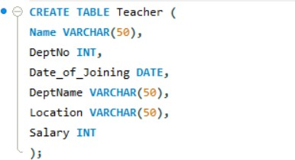

( a ) Insert five records.
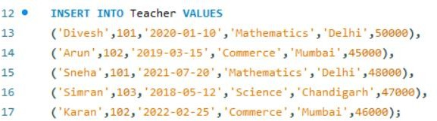
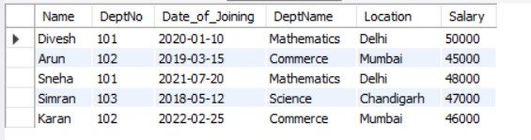

( b ) Give Increment of 25% salary for Mathematics Department .
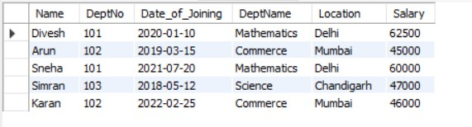

( c ) Perform Rollback command.

( d ) Give Increment of 15% salary for Commerce Department.

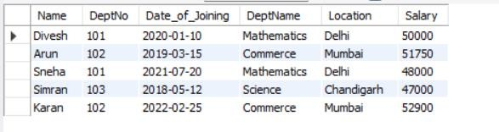

( e ) Perform commit command.

